**EXPERIMENT NO – 05**

(File handling in python)

1. Read operation on file
2. # f = open("sample.txt") ==> to open a file
3. # reding content of file
4. f = open("sample.txt", "r")
5. print(f.read())
6. # to read pirticular no of chatracters from start
7. f = open("sample.txt", "r")
8. print("\nreading first 5 characters......")
9. print(f.read(5))
10. # to read a single line
11. f = open("sample.txt", "r")
12. print("\nreading first line.....")
13. print(f.readline())
14. # to read whole file line by line
15. f = open("sample.txt", "r")
16. print("\n reading file line by line.....")
17. for x in f:
18. print(x)
19. # closing file when u finish with it
20. f.close()

output:

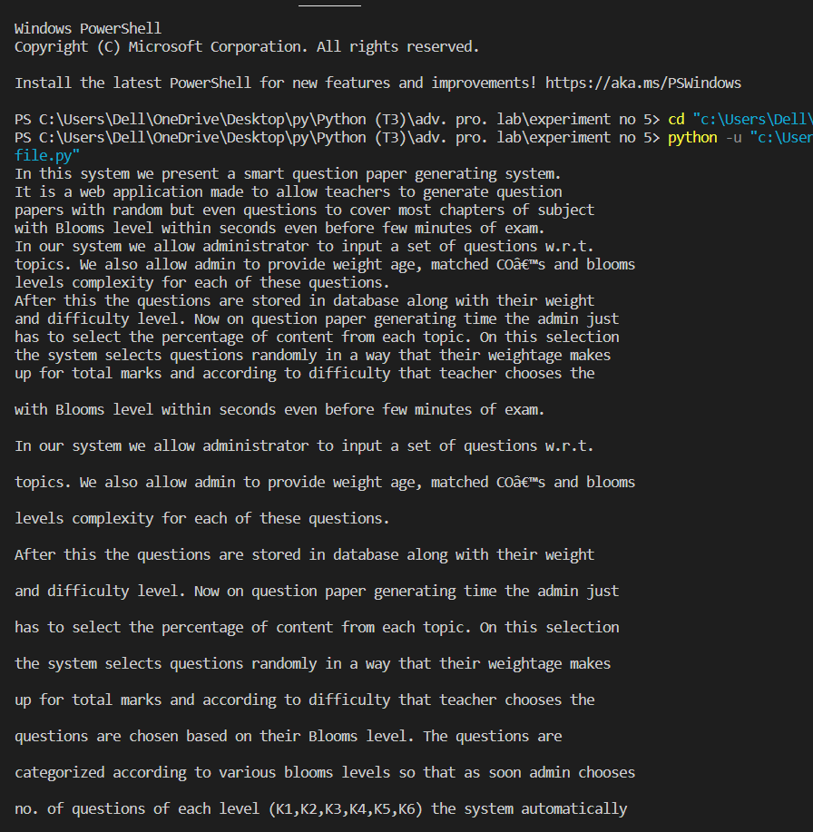

2- write operation on file

# "# "a"- will append the end of file

# "w"- will overwrite any existing contentnt

# 1- appending

f = open("sample2.txt", "a")

f.write("....This content is appended to this file....")

f.close()

#open and read the file after appending

f = open("sample2.txt", "r")

print(f.read())

# 2- writing

f = open("sample2.txt", "w")

f.write("This text is overwritten to file.....")

f.close()

# #open and read file after overwritten

f = open("sample2.txt", "r")

print(f.read())

output:

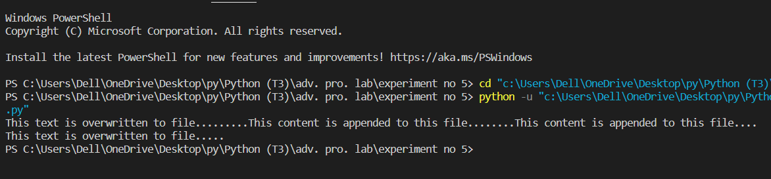

3- read n lines from starting and and last.

# To read first n lines of a file

n = int(input("enter no of lines you want to read:"))

f = open("sample.txt", "r")

print("\nfirst",n," lines are .....\n")

for line in (f.readlines() [:n]):

    print(line,end="")

f.close()

# To read last n lines of a file

n = int(input("\nenter no of lines you want to read:"))

f = open("sample.txt", "r")

print("\nlast",n," lines are .....\n")

for line in (f.readlines() [-n:]):

    print(line,end="")

f.close()

output:

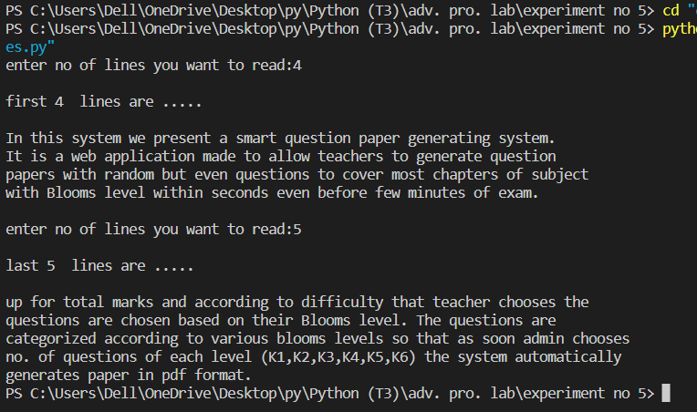

4- creating new file

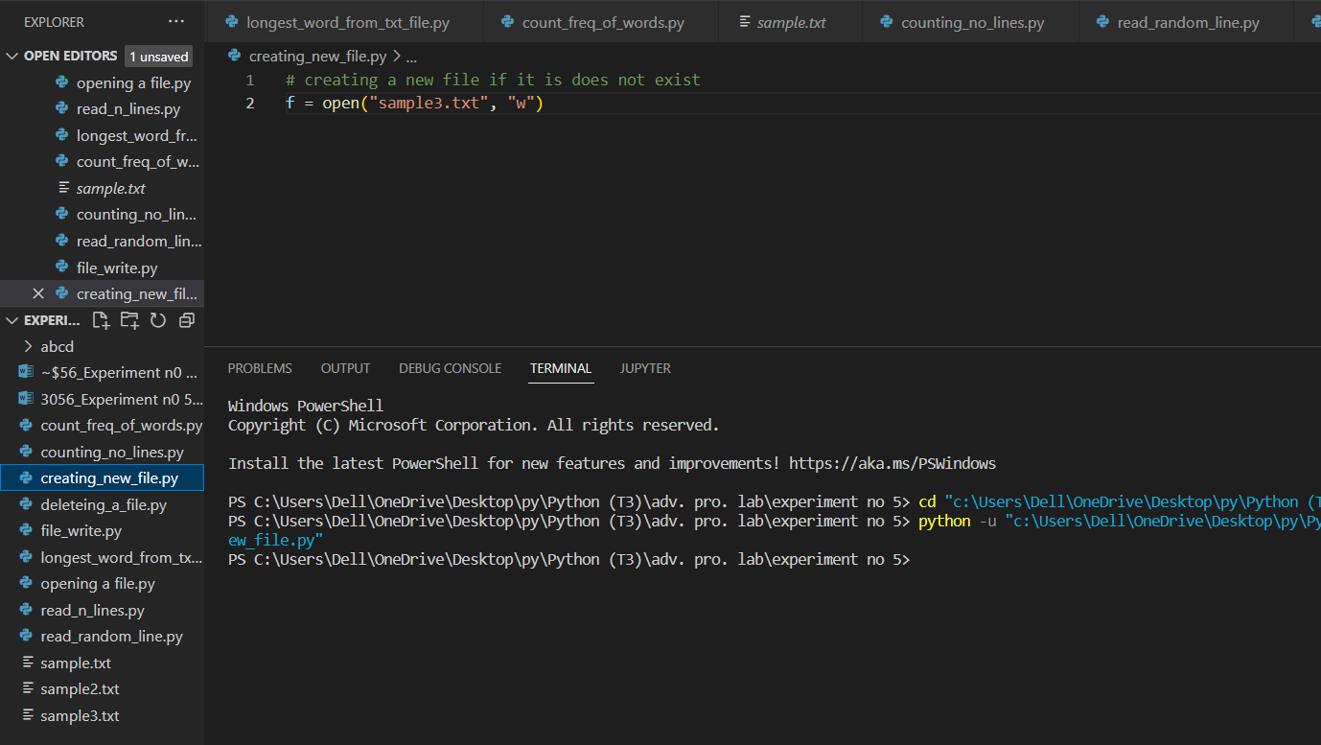

5- deleting a file

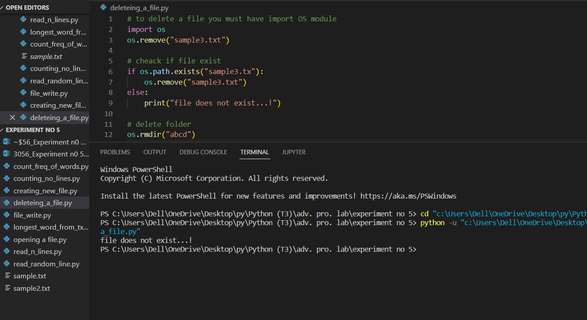

6- counting no of lines in file

# to count no of lines in a text file

f = open("sample.txt", "r") #or     with open("sample.txt", "r") as f ==> no need to f.close()

#make a list of lines

L = f.readlines()

# print(L)

print("no of lines are:", len(L))

f.close()

output:

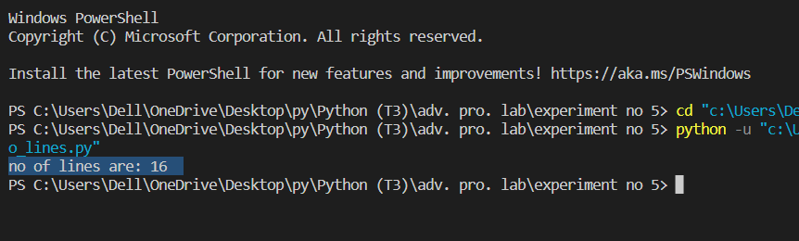

7-counting frequency of words.

from itertools import count

f = open("sample.txt", "r")

word = input("enter the word to be searched:")

s=f.read() # stores the string is s

#make a list

L = s.split()

count=0

for i in L:

    if(i==word):

        count+=1

print("word {} occured {} times".format(word,count))

f.close()

output:

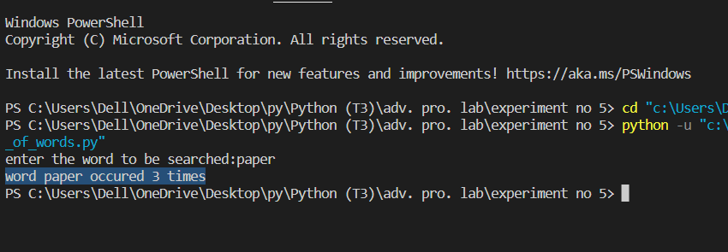

8- read random line from file

# to print random line from a text file

import random

f = open("sample.txt", "r") #or     with open("sample.txt", "r") as f ==> no need to f.close()

#make a list of lines

L = f.readlines()

length = len(L)

r1 = random.randint(0, length-1)

print(L[r1])

f.close()

output:

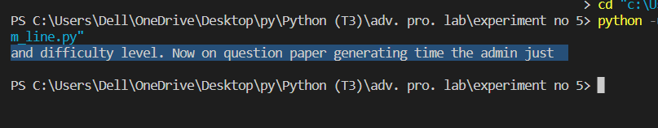

9- min and max length word in file

# to fing longest words in txt file

from http.client import LENGTH_REQUIRED

n = int(input("enter least no of characters that words contains:"))

f = open("sample.txt", "r")

s = f.read()

#make a list according to words seprated by space

L = s.split()

print(L)

for i in L:

    if (len(i)>n):

        print(i)

# to fing biggest word among the all words

print("\nmaximum length words are:",max(L,key=len))

#to fing min length word among the all words

print("\nminimum legth words are:",min(L,key=len))

Output:

